Question 1 - Write a R program to create a sequence of numbers from 20 to 50 and find the mean

of numbers from 20 to 60 and sum of numbers from 51 to 91.

> print(("seq of no "))

[1] "seq of no "

> print(seq(20,50))

[1] 20 21 22 23 24 25 26 27 28 29 30 31 32 33 34 35 36 37 38 39 40 41 42 43 44 45 46 47 48 49 50

> print("mean of 20 to 60")

[1] "mean of 20 to 60"

> print(mean(20:60))

[1] 40

> print("sum of 51 to 91")

[1] "sum of 51 to 91"

> print(sum(51:91))

[1] 2911

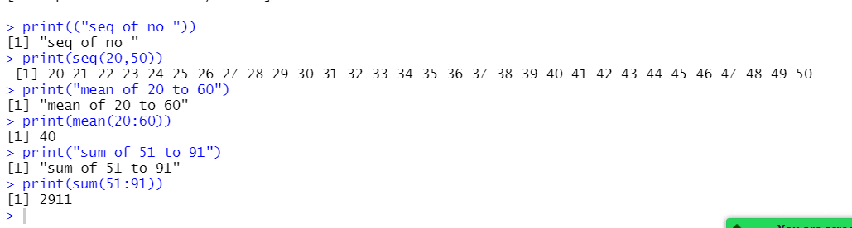

Question 2 - Write a R program to print the numbers from 1 to 100 and print "Fizz" for multiples

of 3, print "Buzz" for multiples of 5, and print "FizzBuzz" for multiples of both.

for (n in 1:100){

+ if (n %% 3 == 0 & n %% 5 == 0) {print("FizzBuzz")}

+ else if (n %% 3 == 0) {print("Fizz")}

+ else if (n %% 5 == 0) {print("Buzz")}

+ else print(n)

+ }

[1] 1

[1] 2

[1] "Fizz"

[1] 4

[1] "Buzz"

[1] "Fizz"

[1] 7

[1] 8

[1] "Fizz"

[1] "Buzz"

[1] 11

[1] "Fizz"

[1] 13

[1] 14

[1] "FizzBuzz"

[1] 16

[1] 17

[1] "Fizz"

[1] 19

[1] "Buzz"

[1] "Fizz"

[1] 22

[1] 23

[1] "Fizz"

[1] "Buzz"

[1] 26

[1] "Fizz"

[1] 28

[1] 29

[1] "FizzBuzz"

[1] 31

[1] 32

[1] "Fizz"

[1] 34

[1] "Buzz"

[1] "Fizz"

[1] 37

[1] 38

[1] "Fizz"

[1] "Buzz"

[1] 41

[1] "Fizz"

[1] 43

[1] 44

[1] "FizzBuzz"

[1] 46

[1] 47

[1] "Fizz"

[1] 49

[1] "Buzz"

[1] "Fizz"

[1] 52

[1] 53

[1] "Fizz"

[1] "Buzz"

[1] 56

[1] "Fizz"

[1] 58

[1] 59

[1] "FizzBuzz"

[1] 61

[1] 62

[1] "Fizz"

[1] 64

[1] "Buzz"

[1] "Fizz"

[1] 67

[1] 68

[1] "Fizz"

[1] "Buzz"

[1] 71

[1] "Fizz"

[1] 73

[1] 74

[1] "FizzBuzz"

[1] 76

[1] 77

[1] "Fizz"

[1] 79

[1] "Buzz"

[1] "Fizz"

[1] 82

[1] 83

[1] "Fizz"

[1] "Buzz"

[1] 86

[1] "Fizz"

[1] 88

[1] 89

[1] "FizzBuzz"

[1] 91

[1] 92

[1] "Fizz"

[1] 94

[1] "Buzz"

[1] "Fizz"

[1] 97

[1] 98

[1] "Fizz"

[1] "Buzz"

>